Nama : Dyas Tri Apriliansyah

NPM : 212310015

No 2

**import** javax.swing.JOptionPane;

**public** **class** Latihan02 {

**public** **static** **void** main(String[] args) {

Biodata myBio = **new** Biodata();

myBio.setFullname(JOptionPane.*showInputDialog*(

**null**,

"Masukan Nama Lengkap :",

"Form Input",

JOptionPane.***QUESTION_MESSAGE***

));

myBio.setAge(Integer.*parseInt*(JOptionPane.*showInputDialog*(

**null**,

"Masukan Umur:",

"Form Input",

JOptionPane.***QUESTION_MESSAGE***

)));

myBio.setAlamat(JOptionPane.*showInputDialog*(

**null**,

"Masukan Alamat:",

"Form Input",

JOptionPane.***QUESTION_MESSAGE***

));

JOptionPane.*showMessageDialog*(

**null**,

"Nama Lengkap :" + myBio.getFullname()

+ "\nUmur :" + myBio.getAge()

+ "\nAlamat :" + myBio.getAlamat());

}

}

Output :

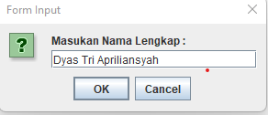

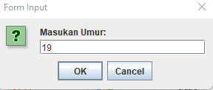

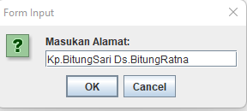

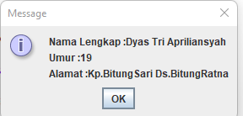

No.3 :

**import** javax.swing.JOptionPane;

**import** java.util.regex.Pattern;

**public** **class** Latihan03 {

**public** **static** **void** main(String[] args) {

String fullname, alamat, age;

fullname = JOptionPane.*showInputDialog*(

**null**,

"masukan Nama Lengkap:",

"Form Input",

JOptionPane.***QUESTION_MESSAGE***

);

age = JOptionPane.*showInputDialog*(

**null**,

"Masukan umur:",

"Form Input",

JOptionPane.***QUESTION_MESSAGE***

);

alamat = JOptionPane.*showInputDialog*(

**null**,

"Masukan Alamat:",

"Form Input",

JOptionPane.***QUESTION_MESSAGE***

);

**if**(fullname.isEmpty() && alamat.isEmpty() && age.isEmpty()) {

JOptionPane.*showMessageDialog*(

**null**,

"Field nama/umur/alamat tidak boleh kosong",

"Error Message",

JOptionPane.***ERROR_MESSAGE***);

}

**else** **if**(!Pattern.*matches*("^[0-9]+$", age)) {

JOptionPane.*showMessageDialog*(

**null**,

"Isian umur harus angka",

"Error Message",

JOptionPane.***ERROR_MESSAGE***);

}

**else** **if**(alamat.length() < 10) {

JOptionPane.*showMessageDialog*(

**null**,

"Masukan alamat minimum 10 karakter",

"Error Message",

JOptionPane.***ERROR_MESSAGE***);

}

**else** {

JOptionPane.*showMessageDialog*(

**null**,

"Nama lengkap : "+fullname+"\nUmur :" + age +"\nAlamat :"+alamat ,

"Output Message",

JOptionPane.***INFORMATION_MESSAGE***);

}

}

}

Output :

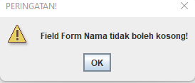

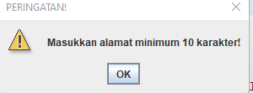

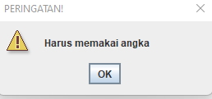

No.4

**import** javax.swing.JOptionPane;

**public** **class** Latihan04 {

**public** **static** **void** main(String[] args) {

JOptionPane.*showMessageDialog*(**null**, "Selamat Datang!");

**final** String WARN = "PERINGATAN!";

**boolean** isLanjut = **true**;

**int** keluar ;

**while**(isLanjut) {

String nama = JOptionPane.*showInputDialog*(**null**, "Masukkan nama lengkap Anda:", "Form Nama", JOptionPane.***QUESTION_MESSAGE***);

**if**(nama.isEmpty()) {

JOptionPane.*showMessageDialog*(**null**, "Field Form Nama tidak boleh kosong!", WARN, JOptionPane.***WARNING_MESSAGE***);

System.*exit*(0);

}

String usia = JOptionPane.*showInputDialog*(**null**, "Masukkan usia Anda:", "Form Usia", JOptionPane.***QUESTION_MESSAGE***);

**final** String REG_NUMERIK = "[0-9]+";

**if**(usia.isEmpty()) {

JOptionPane.*showMessageDialog*(**null**, "Field Form Usia tidak boleh kosong!", WARN, JOptionPane.***WARNING_MESSAGE***);

} **else** **if**(!usia.matches(REG_NUMERIK)) {

JOptionPane.*showMessageDialog*(**null**, "Isian Form Usia harus numerik!", WARN, JOptionPane.***WARNING_MESSAGE***);

System.*exit*(0);

}

String alamat = JOptionPane.*showInputDialog*(**null**, "Masukkan alamat Anda:", "Form Alamat", JOptionPane.***QUESTION_MESSAGE***);

**if**(alamat.isEmpty()) {

JOptionPane.*showMessageDialog*(**null**, "Field Form Alamat tidak boleh kosong!", WARN, JOptionPane.***WARNING_MESSAGE***);

} **else** **if**(alamat.length() < 10) {

JOptionPane.*showMessageDialog*(**null**, "Masukkan alamat minimum 10 karakter!", WARN, JOptionPane.***WARNING_MESSAGE***);

}

// int pUsia = Integer.parseInt(usia);

JOptionPane.*showMessageDialog*(

**null**,

"Nama lengkap : "+nama+"\nUmur :" + usia +"\nAlamat :"+alamat ,

"Output Message",

JOptionPane.***INFORMATION_MESSAGE***);

keluar = JOptionPane.*showConfirmDialog*(**null**, "Apakah Anda ingin keluar?", "Keluar?", JOptionPane.***YES_NO_OPTION***);

**if**(keluar == JOptionPane.***YES_OPTION***) {

isLanjut = **false**;

} **else** {

isLanjut = **true**;

}

}

JOptionPane.*showMessageDialog*(**null**, "Terima kasih!");

}

}

Output :

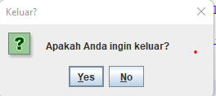

Jika Yes

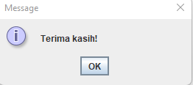

Jika No

